KARNATAK LAW SOCIETY’S

GOGTE INSTITUTE OF TECHNOLOGY

UDYAMBAG, BELAGAVI-590008

(An Autonomous Institution under Visvesvaraya Technological University, Belagavi)

**(APPROVED BY AICTE, NEW DELHI)**

Department of Electronics and Communication Engineering



*Course Activity Report on*

**Employee Details of Company**

**in**

***C/C++***

***Submitted by***

*Vaibhav Nitsure(2GI17EC152)*

*Utkarsh Topinkatti(2GI17EC151)*

*Swapnil Chillal(2GI17EC148)*

*Shubham Dukare(2GI17EC132)*

**Guide**

Prof. Uttam Deshpande

(Assistant Professor)

**2018-19**

**EMPLOYEE DETAILS OF COMPANY**

**Objective:**

To access the employee’s personal details and his/her work details in a company.

**CODE:**

#include<iostream>

#include<string.h>

using namespace std;

int e[5]={1,2,3,4,5}; // Employee's id

string n[5]={"Chandler","Phoebe","Rachael","Monica","Ross"}; //Employee's name

string d[5]={"ECE","ECE","ECE","CSE","ECE"}; //Employee's department

int y[5]={10,20,15,10,10}; //Year of experience of employee

int p1[5]={111,222,333,444,555}; //password assign to employee to access personal details

string res[5]={"Nilaya","Samaya","Pranaya","Anaya","Amma"}; //Name of the residency

float sala[5]={20000,20000,25000,20000,25000}; //Salary of employee

int i,id,j;

//Employee class which is used as structure to store above details

class emp{

private:

float sal; //Salary of employee

string home; //Name of the residency of employee

int hono; //ID used as house number

int blno; //Password used as block number

public :

int empno; // Employee's id

string name; //Employee's name

string dept; //Employee's department

int yoe; //Year of experience of employee

int p; //password assign to employee to access personal details

//function used to validate password and provide the personal details

void passw(string a,float s,int h,int b)

{

int pasw;

home=a;

hono=h;

sal=s;

blno=b;

cout<<"Enter the employee password :"<<endl;

cin>>pasw;

if(pasw==p)

{

cout<<"Residence :"<<home<<"\nHome No :"<<hono<<"\nBlock No :"<<blno<<endl;

cout<<"The salary package is :"<<sal<<"/month"<<endl;

}

else

{

cout<<"The Password is Incorrect"<<endl;

}

}

};

emp c[5]; //Defining array with size 5 for 5 employees

int main()

{

string nam;

char choice,ch;

for(i=0;i<5;i++) //loop to access details of one employee

{

c[i].empno=e[i];

c[i].name=n[i];

c[i].dept=d[i];

c[i].yoe=y[i];

c[i].p=p1[i];

}

enter:

cout<<"Enter the employee ID"; //input the id of employee

cin>>id;

for(j=0;j<5;j++)

{

if(id==c[j].empno) //check if id exist or not

{

na:

cout<<"Enter your name :"; //input name of employee

cin>>nam;

if(nam==c[j].name) //check if name exist or not

{

//output the work details

cout<<"ID NO. :"<<c[j].empno<<endl<<"Emp loyee name :"<<c[j].name<<endl<<"Department of work :"<<c[j].dept<<endl<<"Years of experience :"<<c[j].yoe<<endl;

c[j].passw(res[j],sala[j],e[j],y[j]); //function call to access the personal details

cout<<"Do you need to change the personal info. y/n"<<endl; //to update personal details

cin>>choice;

if(choice=='y') //enter new residance name,House number,block number

{

cout<<"Enter the name of residence :"<<endl;

cin>>res[j];

cout<<"Enter the Home number :"<<endl;

cin>>e[j];

cout<<"Enter the Block number :"<<endl;

cin>>y[j];

}

else

{

cout<<"Press 'e' to exit or 'c' to continue: "<<endl; //to exit or continue

cin>>ch;

if(ch == 'e'){exit(0);}

cout<<"**********THANK YOU**********"<<endl;

}

}

else

{

cout<<"The name entered is INCORRECT\n";

goto na; //branch to label na if name is incorrect

}

}

}

goto enter; //branch to label 'enter' to access details of another employee.

}

**INPUT/OUTPUT:**

**Sample Input/output 1:**

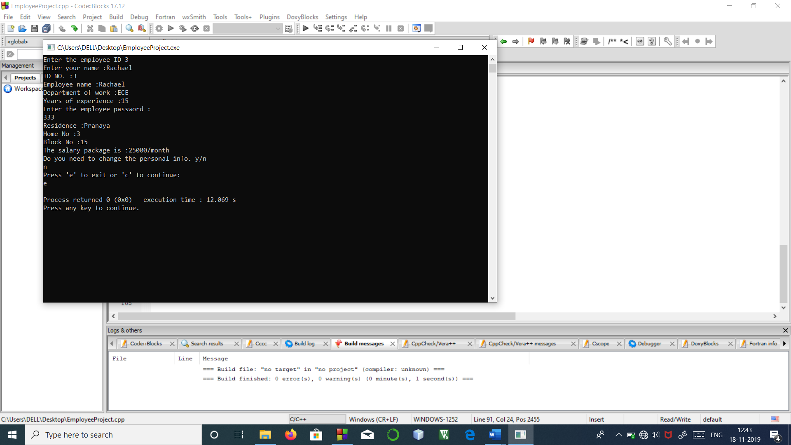

**Sample Input/output 2:**

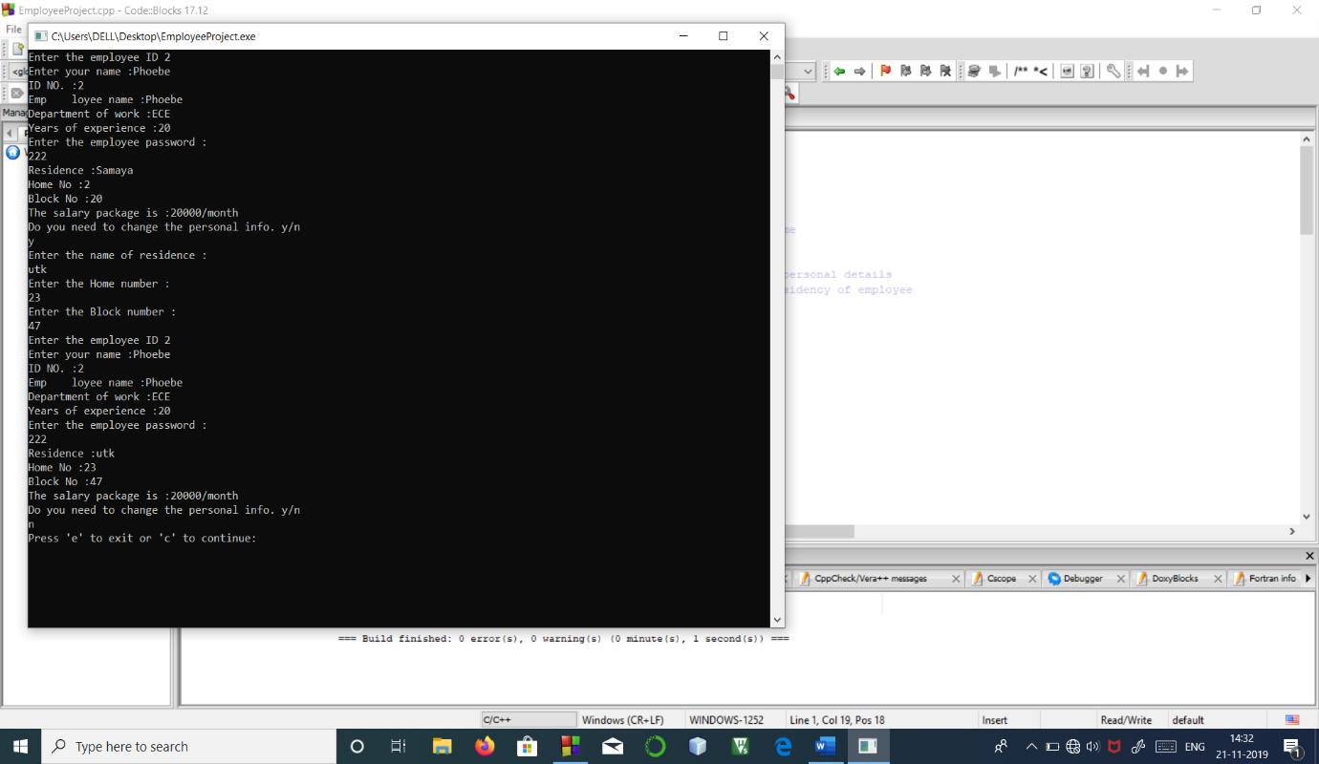

**Limitations:**

1)The code has restricted stored data.

2)The code can’t update its company details except its personal details.

**Improvements:**

1)Dynamic memory allocation can used to add new employees’ details.